Iteration 6 – Development log
This iteration will be about creating the calculators for the project.

Firstly, after researching solutions to how we can create a calculator for Carbon footprints, I found out that it would be very difficult to implement my own custom implementation. Therefore, I decided to look at free alternatives online that other people have already made.

I decided to use a form builder by Elfsight. It’s free and they say I can use it on my website. That is what I did first:
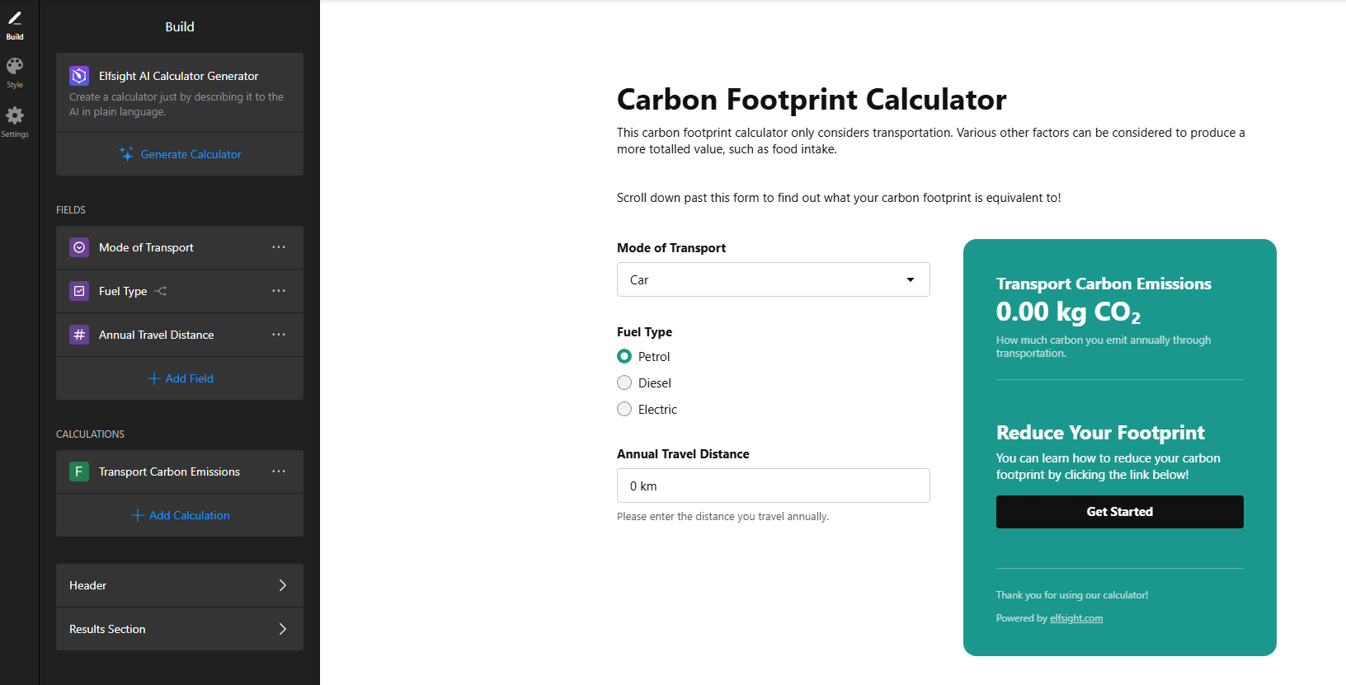
I then implemented this onto the webpage:
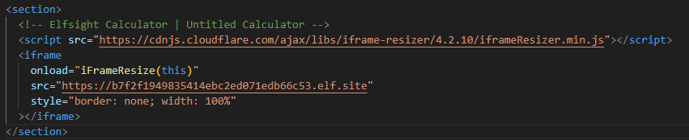

Furthermore, I thought it would be useful for users to know what their footprint was equivalent to, so I found a calculator for that as well:
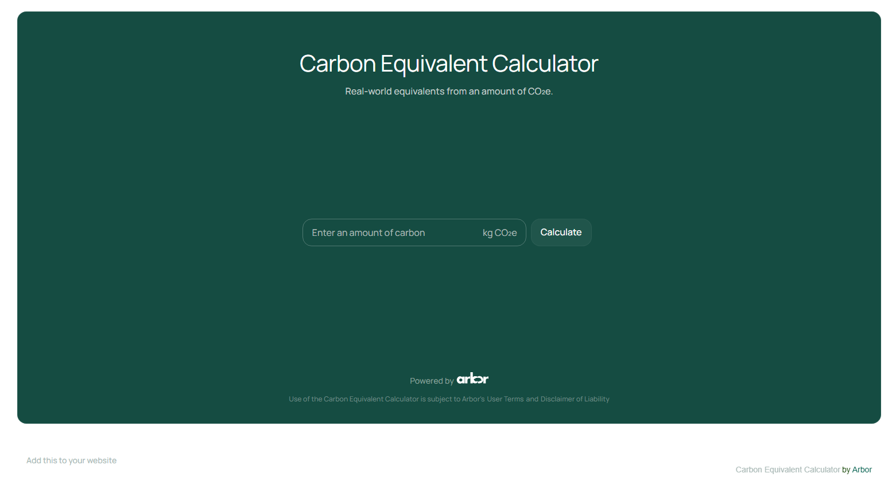

I made sure to properly include credits for both solutions (even though they both don’t explicitly specify I must do so).

If I have time, I will come back and do the other calculators. I think, however, that other aspects of the project are more important, so I will complete those iterations first.

